# Name: Abdurrahman Qureshi

# Roll no: 210451

## Practical no 4: -

## Aim: Execute SQL Queries based on DDL commands

Question 1: - Create a table employee with the following schema: -

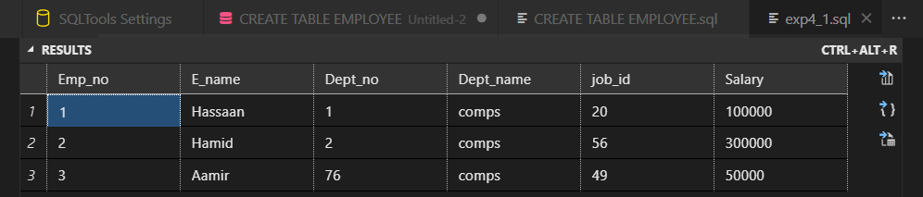Emp (Emp_no as primary key, E_name, Dept_no, Dept_name, Job_id, Salary)

Question no 2: Create the table EMPLOYEE and DEPARTMENT with the following schema by applying

Primary key and foreign key:

Emp (empno as primary key, empname, salary, phno)

Dept (deptno primary key, empno foreign key, deptname,location)

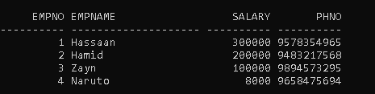.

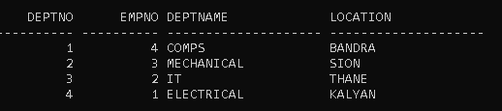

Question no 3: -Create a table for stud using attributes Roll no, stud name, percentage and apply

Primary key for roll no and check constraint on percentage should not greater than 100.

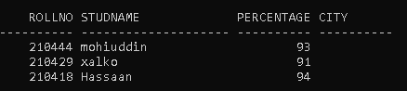

Question no 4: - change the stud table structure by adding column city.

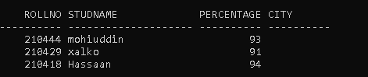

Question no 5: -increase the size by 10 of student name column

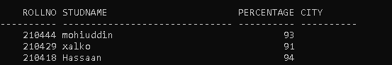

Abdurrahman

Question no 6: -Write the output of the following:-

|  |  |
| --- | --- |
| 1. Create table   Passenger_details(passenger_Name  Varchar2(30),train_details varchar2(30),travelling_date date ,  Birthdate date); | Write output here:- |
| 1. Alter table stud add column   Ticket_cost number; |  |